
Workday Recruiting Quick Guide
Reviewing and Moving Candidates:
- Log in to Workday.
- From your homepage, click the Recruiting Dashboard worklet in the Apps menu.
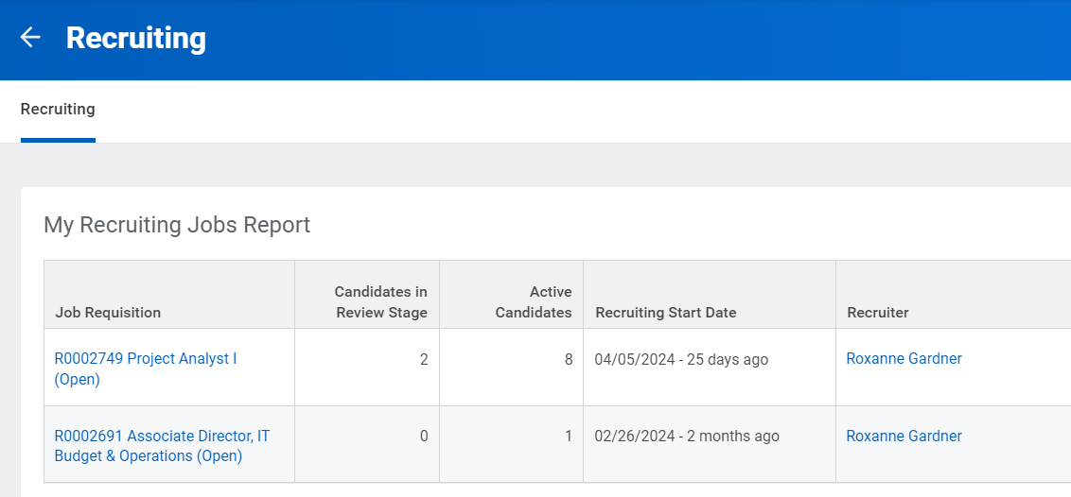
- Click a Job Requisition to review candidates.
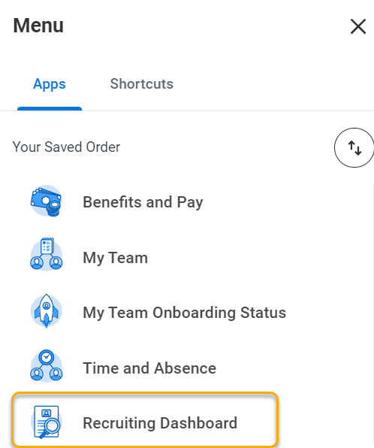

- The applicant funnel on this screen provides a graphical representation of the recruitment process and the number of candidates at each step. The table below contains a brief description of each step.
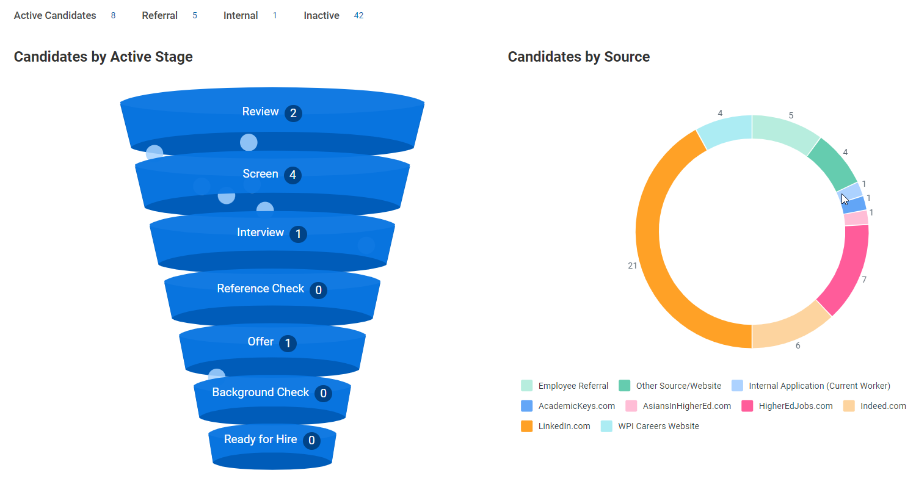

Recruitment Workflow
Step | Completed By | Description
Review | Hiring Manager | Candidates are automatically placed in the Review step upon completing their online applications. Managers can move new candidates to the Screen step for further consideration or remove them from consideration.
Initial Screen | Hiring Manager | The Screen step is used when hiring managers have reviewed online applications and phone screens are conducted.
Interview | Hiring Manager | The Interview step is used to capture virtual and in-person interviews. Please ensure to add all interviewer names and dates of interviews for each candidate.
Final Interview | Hiring Manager | The Final Interview step is used to capture final rounds of interviews. Please ensure to add all interviewer names and dates of interviews for each candidate.
Reference  Check | Hiring Manager | The Reference step is used when hiring managers identify their candidate of choice and request professional references. Hiring managers complete a minimum of three references, including at least one former or current supervisor. Reference feedback is uploaded on candidate’s profile in the Attachments tab under Other Documents.
Offer | Manager/Recruiter | Offer details are submitted by hiring managers or primary recruiter. Verbal offers of employment may be extended by hiring managers upon Workday approvals. Primary Recruiter will send official offer in Workday.
Background Check | Recruiter | Background checks are completed through our partner HireRight. WPI conducts appropriate background verifications depending on the position type,  requirements, and responsibilities.
Ready for  Hire | Recruiter | Candidates are ready for hire after successful completion of the background check and providing personal information to set up new WPI account.

Workday Actions
Note: Only the hiring manager and primary recruiter can advance candidates (search committee members can only view applications and materials.)
At Review step - open the candidate's application by clicking on their name and you have the option to press Move Forward, Decline or press the Review button in the Awaiting Me column.
Moving Forward you can choose:
  - Initial Screen – initial contact with candidate via phone screen or email.
  - Interview –Zoom or in person interviews.
  - Final Interview – on-campus interviews; candidate meets with all participants – typically this step reflects a second interview or final round of interviews.
  - Reference Check – request for professional references and feedback is uploaded on the candidate’s profile.

Initiating Offer:

Once the candidate has been moved to Reference Check and reference checks are completed, click Review under Awaiting Me column and you will see the Offer button.
- Choose Offer then Open under Awaiting Me
- Enter Hire Date, Reason, and End Date if applicable.
- Change Business Title if needed as it defaults from job profile which might be different
- Review info and click Submit
- Click Open under Awaiting Me column
- Scroll down to Salary or Hourly block and click on pencil icon to change annual salary and hourly rate under Assignment Details if needed.
- Click Submit

Offer Approval Flow:
After submitting offer details, the offer will go through an approval process to approve or send back for more information:
- Manager (only if they did not submit the offer details)
- Operations Manager
- Dean/Staff Approver
- Division Approver
- Budget
- Primary Recruiter to approve then generate and send offer letter

Dispositioning Candidates:
Note: Any candidate remaining in Review or Screen step will receive an automated email they were not selected when the background check completes for the candidate you hire. You do not have to move these candidates if you want them to receive the email. If you want them to be notified prior to that, you can follow these steps:
- Open the candidate's application by pressing their name and press on Decline or Press the Review button in the Awaiting Me column
- Choose a reason from the list provided. Candidates do not see the reason.
- Candidate receives a generic email letting them know they were not selected.
  - Not Interviewed – Do Not Send Letter and Interviewed – Do Not Send Letter reasons do send a notification. These reasons can be used for the candidates that you personally notified or have already been notified they were not moving forward.

