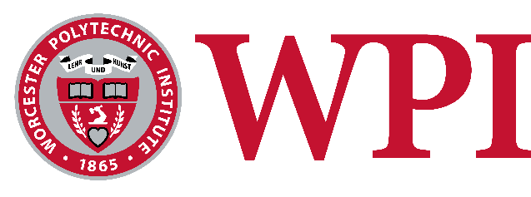

School of Arts & Sciences
Summer Training in Arts and Sciences Research (STAR) Fellowship Program
Application Deadline: March 17, 2026

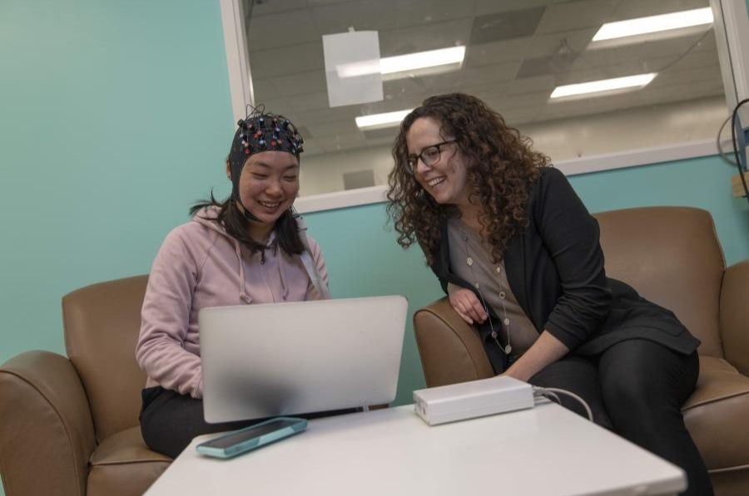
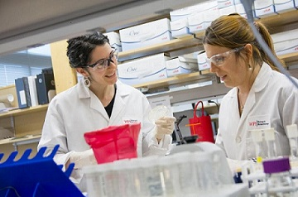

The School of Arts & Sciences is pleased to announce that student applications are being accepted for the 2026 Summer Training in Arts & Sciences Research (STAR) Fellowship program. These fellowships will support current WPI sophomores and juniors who seek to conduct A&S research projects full-time for two months during the summer of 2026, with a faculty research mentor. These awards are generously funded by the A&S Advisory Board. Funding is competitive and limited.
To be funded, students must major in and propose a research project in one of the arts & sciences disciplines (this includes all majors and programs under the A&S departments, including robotics engineering).
STAR Fellows will participate in summer professional development workshops with other WPI summer undergraduate researchers, present a poster at a summer research showcase, and conduct a presentation as part of WPI’s Fall A&S Week. Recipients will be asked to sign a letter of commitment outlining student responsibilities for the fellowship prior to their appointment.
Eligibility:
All current WPI sophomores and juniors who are pursuing a major in a department or program in the Arts & Sciences are eligible for these fellowships.
Deadline: Applications are due by Tuesday, March 17, 2026. Click here to apply.
Application Process:
Students are responsible for proposing a research project. Students should start by discussing their interests and project ideas with potential faculty research mentors with expertise in that research area. Once the student has identified a faculty research mentor and project, the student submits the following materials using the online application:
- Brief description of the research project and how the work fits into the student's academic plan or career goals
- Brief personal statement on the student's relevant experience (including course work, independent study, or projects that show the student's ability to work through open-ended questions)
- Resume
- Letter of support from faculty research mentor for the proposed research project
- Other supporting materials (optional).
The brief descriptions of the proposed research project and the applicant’s relevant experience should each be limited to 500 words or fewer.
Fellowship Award Details and Stipend
- This is a full-time appointment for two summer months (students will negotiate start and end dates with their faculty research mentor).
- The stipend is $6,000 total: $3,000 paid at the end of June; $3,000 paid at the end of July.
Questions? Please contact Alicia Briggs in the Office of the Dean of Arts and Sciences at abriggs@wpi.edu.

David LaPre Summer Research Fellowship in Chemistry & Biochemistry

Eligibility: The applicant needs to be a WPI student majoring in chemistry or biochemistry. All first year, sophomore, and junior CBC students are eligible for the program. Two awards will be offered.
Stipend: $6,000
Duration: 10 weeks (between May 25th – August 7th, 2026)
Application Deadline: March 17th, 2026
Application Process
- Applicants should start by discussing their interests with potential faculty research supervisors.
- The student submits the following materials as an attachment (PDF only please!) to Ms. Jacqueline Alibrandi (jalibrandi@wpi.edu) :
  - A brief statement (approximately 100 words) of your reasons for pursuing summer research activities;
  - A brief description (approximately 100 words) of your specific research project and your relevant experience;
  - A resume;
  - Other supporting materials (optional, PDF only).
- After the student has submitted the required material, the student notifies the faculty supervisor who will send a brief letter of support to Ms. Alibrandi (jalibrandi@wpi.edu)
- The student's unofficial transcript from Workday will be added by the department to the application.
Notification
- Notification of awards will begin Monday, April 6th, 2026.

