Sequencing leaf disc assay with related lessons.
For Grade 9 Biology students:
In its simplest form (see leaf disc assay protocol), the assay was used for grade 9 Biology students. This was done as a partnership between our Biotechnology vocational shop at Worcester Technical High School (WTHS) and Dave Clark, a Grade 9 Biology teacher at WTHS. Mr. Clark has a diverse group of students and a large number of these are special education students. The purpose of the partnership was to help his students better understand the process of photosynthesis in preparation for their MCAS exams. The leaf disc assays allows the following abstract concepts to become concrete: 1) the depletion of gas from the leaves as they sink 2) the addition of a carbon source that will be needed for the reaction 3) the requirement for light as they place their assays under the lights 4) the production of oxygen as they watch small bubbles form on the discs 5) the floating of the discs as gas gets trapped in the mesophyll.
To engage his students’ thought processes further, Dr Clark provided a set of questions for the students to answer after the activity. (See leaf disc assay questions)

For Biotechnology shop and AP Biology students:
In our Biotechnology shop, the leaf disc assay was used at the end of a photosynthesis unit. The students used it to test their hypotheses on which wavelength of light would best support photosynthesis. Their hypotheses were based on data from several experiments. The sequence of activities are listed below. Not all of the activities are possible for every classroom because of equipment requirements. Alternatives are given in these cases.
1. Determination of the light absorption/emission properties of a set of colored filters.
Students eventually use the data from this activity to test their final hypothesis using the leaf flotation assay. At the end of these 4 activities, most students come to the conclusion that the filter which transmits the wavelength range closest to their chlorophyll absorption spectrum, should work best in the leaf disc assay.
A spectrophotometer is needed for this activity. If one does not have a spectrophotometer, a published color wheel can be used to predict which filters should transmit the required wavelength for chlorophyll. To do this activity, students insert pieces of plastic filters into cuvettes and measured their absorption and then transmission at 20nm intervals at wavelengths set from 420 to 620nm.
Students had to graph their 2 sets of data to prompt them to realize that the functions are reciprocal. For example, the red filter absorbed 540nm light best and transmitted none of it. Some representative graphs from a student’s notebook are shown below.
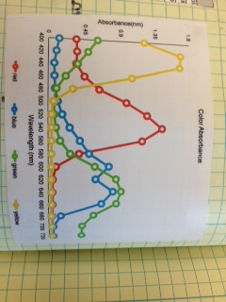

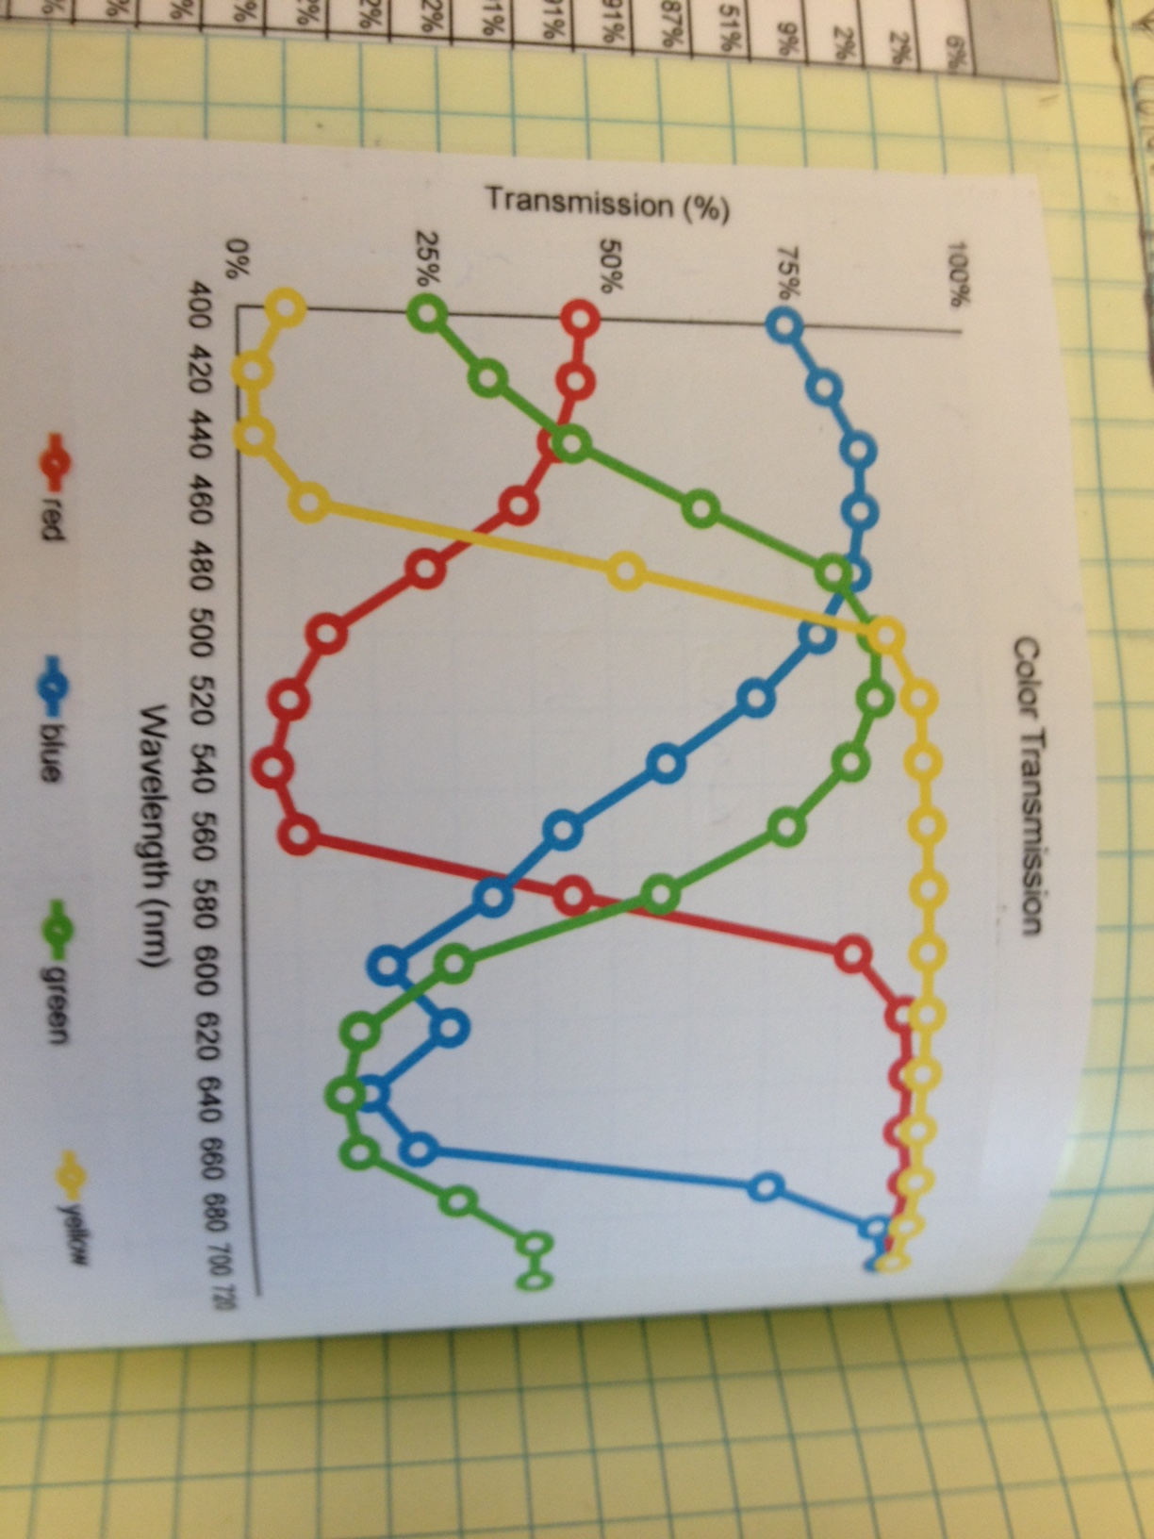

2. Isolation of chlorophyll and determination of its absorption, transmission properties.
Students extracted ethanol soluble plant pigments using the procedure provided. The extract was used both for chromatograms and for spectrophotometer readings. The chromatograms allowed the students to see the relative abundance of chlorophyll as compared to other pigments such as carotene and xanthophyll. They also need to observe the presence of these other pigments to understand their data from their spectrophotometer measurements. Some students will incorrectly predict that the wavelength range best absorbed by chlorophyll should match that of the color green and therefore they should use a green filter. These students should be prompted to re-examine their chlorophyll absorption graph and color filter transmission graph (or published chlorophyll spectrum and color wheel of color transmission).
A photo of a chromatogram from a student’s notebook and the absorption spectrum from the extract is shown below. Some students used choke cherry leaves rather than spinach. This invasive species grows wild right outside of our shop. The resulting data was very similar to that of spinach. They used choke cherry for the chromatography, absorption spectrum and leaf disc assay. To make the chromatogram one only needs a 1 to 2 cm wide, 12 cm long strip of whatman filter paper. A coffee filter works as well. A pencil line is drawn across the width of the paper, about 2 cm up from the bottom. 10 mls of 95% ethanol is placed in a 100ml beaker. A 10-20 ul drop of extract is placed on the pencil line and the other end is wrapped around a pencil and taped in place. The pencil is placed across the top of a beaker so that the bottom of the filter strip is touching the ethanol. It is important that the ethanol in the beaker not contact the drop of extract since there has to be a slow migration of the pigment up the filter strip as the ethanol is drawn up from the beaker and travels upward into the strip. We let the separation of pigments in the extract take place overnight. There are many variations of this activity. Some include grinding the leaves with sand. At the link below you will see a demonstration of how to set up the chromatogram as well as relevant theory on paper chromatography: http://www.biologyjunction.com/chromatography_plant_pigments.htm
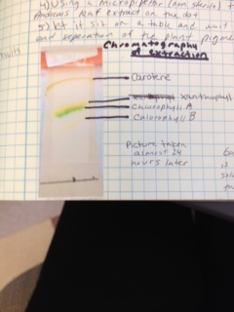
Chromatogram of choke cherry leaf extract from a student’s notebook.
The students researched the migration of leaf pigments on a chromatograph and identified their color bands according to the literature.

Making the chromatogram of the ethanol leaf extract is doable in most high school classrooms. The subsequent spectrophotometer readings of the extracts may not be possible but the absorption spectra of the major leaf pigments are published and students can use this to formulate their final hypothesis. Below is a representative absorption graph from a student’s notebook.
When students graph and analyze their spec readings of the pigment extracts at various wavelengths (as in activity 1 above with the filters) they note that there are two very separate absorption peaks. If they consider their chromatogram results, many come to the conclusion that there is carotene in the extract and this results in a second peak.
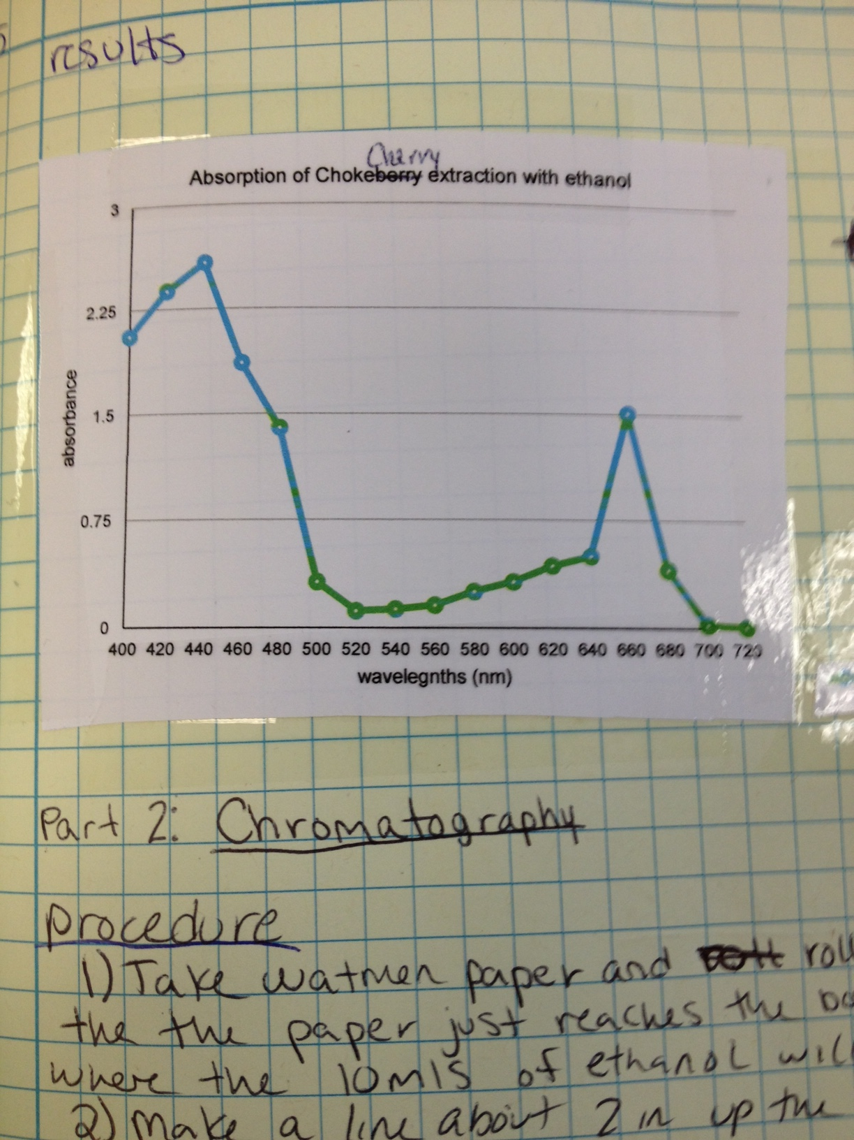

3. The leaf disc assay
The protocol for the leaf disc assay is described in a separate document. (See leaf flotation assay) Students first work out the assay such that half of their discs are floating within 10 mins or less. This involves some trial and error work such as adjusting the distance between the discs and the light or becoming adept at degassing the leaves etc. The students continue practicing until they are comfortable with the assay. They then formulate a hypothesis on which color filter they think will result in the fastest and slowest rate of photosynthesis. They base their hypothesis on the data acquired through activity 1 and 2 above. (If activities 1 and 2 are not possible, published absorption spectra of chlorophyll and color wheels of absorption and transmission at different wavelengths. can be distributed.)
Students test their hypotheses by placing different color filters on top of the petri dishes at the start of the assay and recording the time when 50% of the discs have risen. Most students found that the blue filter which transmits the wavelength of light best absorbed by chlorophyll resulted in the fastest time.
The protocol for this assay can be found in a separate document. It is a good idea to show the students a Bozeman video demonstrating the assay, before they actually perform it. The degassing of the discs can take some practice. Here is the link to that video:
https://www.youtube.com/watch?v=ZnY9_wMZZWI

Related theory
During the weeks when these activities were taking place, students were also learning about the light dependent reactions and Calvin Cycle. This type of detailed background is not needed for the activities outlined above.
As they learned about the Calvin cycle and involvement of Rubisco, they also isolated spinach chloroplasts by density gradient centrifugation and then analyzed the chloroplast proteins by SDS PAGE This allowed them to identify the Rubisco heavy chain as well as note its relative abundance to other chloroplast proteins. The isolation of chloroplasts requires a clinical/swinging bucket centrifuge. Organelle isolation is part of the state frameworks in Biotechnology.

