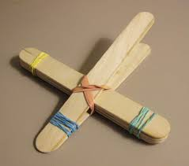
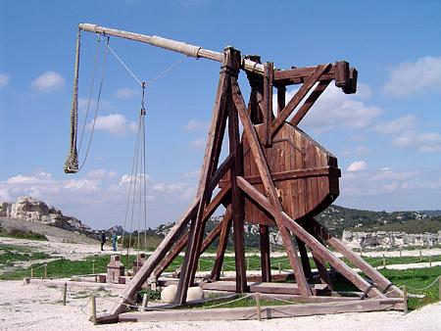
Popsicle Stick Catapult
Materials
- 6 popsicle sticks
- 5 rubber bands
- Safe projectiles (cotton balls, mini marshmallows)

Procedure –

1. Stack four popsicle sticks. Using a rubber band at each end, squeeze the bundle tightly together.
2. Place the remaining two popsicle sticks together. Bundle only one end together using an additional rubber band.
3. Pry the unbundled end open enough to be able to slide the set of four sticks in between perpendicularly to form a cross. Slide the bundle of four sticks down as closely as you can get it to the rubber band that’s holding the two sticks together.
4. Finish your catapult by securing the body to the wings (diagonally at the point where the popsicle sticks intersect) by crisscrossing a rubber band from the back of the right wing to the front of the left several times. Repeat with the final rubber band.
5. Place your projectile at the end of the popsicle stick that is highest in the air. Hold the set of four sticks with one hand, and push down on the angled stick just behind the projectile.
6. Release your projectile!

-A catapult uses stored energy to launch a projectile. In our catapult, the energy is stored by changing the shape of the popsicle stick from what it normally would be.

QUESTION: Energy needs to come from somewhere. Where does the energy come from to power your catapult?

-Catapults were used in warfare for centuries, especially to damage structures, and are a great example of the power of a lever in action.

QUESTION: What other materials might make good projectiles? Safely try a few different options and observe the differences.

-Changing the construction of your catapult will change the way it works. For example, how far the cross bar is from the front, or how many popsicle sticks are used. Engineers try to build the best tools by thinking about what will work well, testing, measuring what happened, and changing their plans based on those experiments.

QUESTION: What can you change in your catapult? Try two changes, and make two observations about what happens when you use it.

DO try this at home! Experiment with different materials and designs to create new catapult variations.

