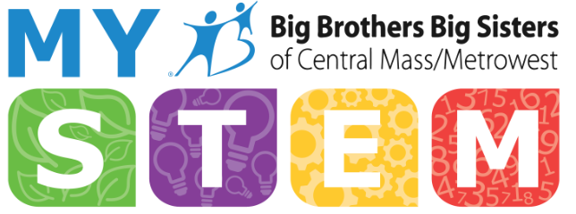
Mentoring youth in Science, Technology, Engineering, and Mathematics
The STEM Institute by Big Brothers Big Sisters Central Mass / Metrowest
BBBS Vision: all children achieve success in life.
MySTEM Vision: all children can enjoy STEM.

BBBS Mission: provide children facing adversity with strong and enduring, professionally supported one-to-one relationships that change their lives for the better, forever.
MySTEM Mission: provide children with enjoyable STEM engagement opportunities within the BBBS mentoring model to encourage self-esteem and provide opportunities to explore STEM careers.
Why STEM Mentoring?

Low self-esteem in STEM is a barrier to entry (esp. for women and minorities)
Lack of role models in STEM is a barrier to entry (esp. for women and minorities)
STEM learning can enrich our matches, potentially raising AML and outcomes
STEM careers are high-paid, rewarding, and hiring (achieve success in life)
Promote STEM literacy (major life skill)
Leverage existing resources in our community partners (MathWorks, Bose, et al.)

Effective Messages about STEM:
STEM is creative.
STEM helps people in both big and personal ways.
STEM is about collaboration.
Failure is not an option … it’s a requirement!

What kids usually think about STEM:
You need to be very good at math and memorizing
Hard hats, nerds, complicated computers, hours alone in the lab

Mentoring can be a pathway to engage young women, underrepresented minorities, and socio-economically disadvantaged youth.

Mentors can help their Littles learn that science is not knowing all the answers, but the questions and the process of exploration. Our Littles are able to engage in STEM learning in our one-on-one model without fear of grades or social pressures.

The National Research Council developed 6 strands of STEM learning for out-of-school time:
- Developing an interest in science
- Understanding science knowledge
- Engaging in scientific reasoning
- Reflecting on science
- Engaging in the scientific process
- Identifying with the scientific enterprise
From Surrounded by Science: Learning Science in Informal Environments (NRC, 2010)

A mentor is:
- A consistent, trusted friend
- A positive role model
- A coach
- An advocate
A mentor is not:
- A social worker or therapist
- A parent
- An ATM
- A babysitter
- A disciplinarian
A good mentor:
- Personal commitment and consistency
- Patience and persistence
- Open and accepting
- Fun and safe
- Problem solver, prepared for the unexpected
- Models behavior
- Realistic Expectations

Sites participating in Big Brothers Big Sisters Programs in Worcester:

Worcester Area College Mentoring Program (WACMP) - College students mentor elementary and middle school children in the Worcester area.
Colleges participating include: WPI, Clark, Holy Cross, and Assumption
Participating sites: Belmont Street Community School, Wawecus Road School, Goddard School, Woodland Academy, Worcester Arts Magnet, Canterbury Street Magnet, Elm Park Community School, Flagg Street School, Girls Inc., and the Tainter, Plumley, Great Brook Valley Boys and Girls Clubs.

Are you at one of these schools? Do you have students that attend one of the Boys and Girls Clubs or Girls Inc.? You can refer a child to our program!

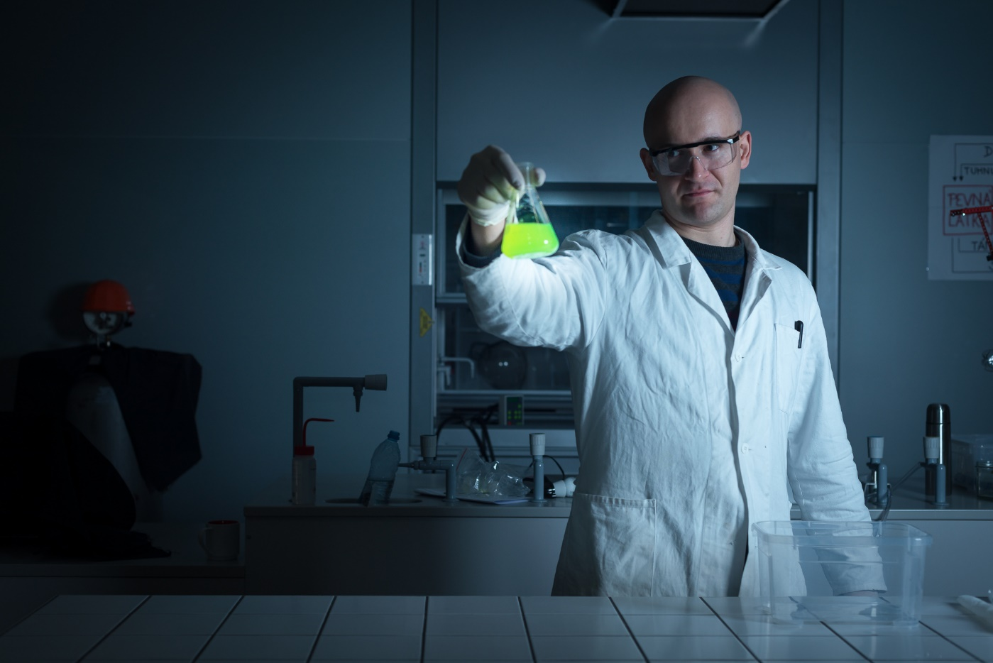
Popular Images of a scientist:

On a sheet of paper: Describe this person. What does he make you feel? What do you think work is like for him?

Popular image of an engineer:
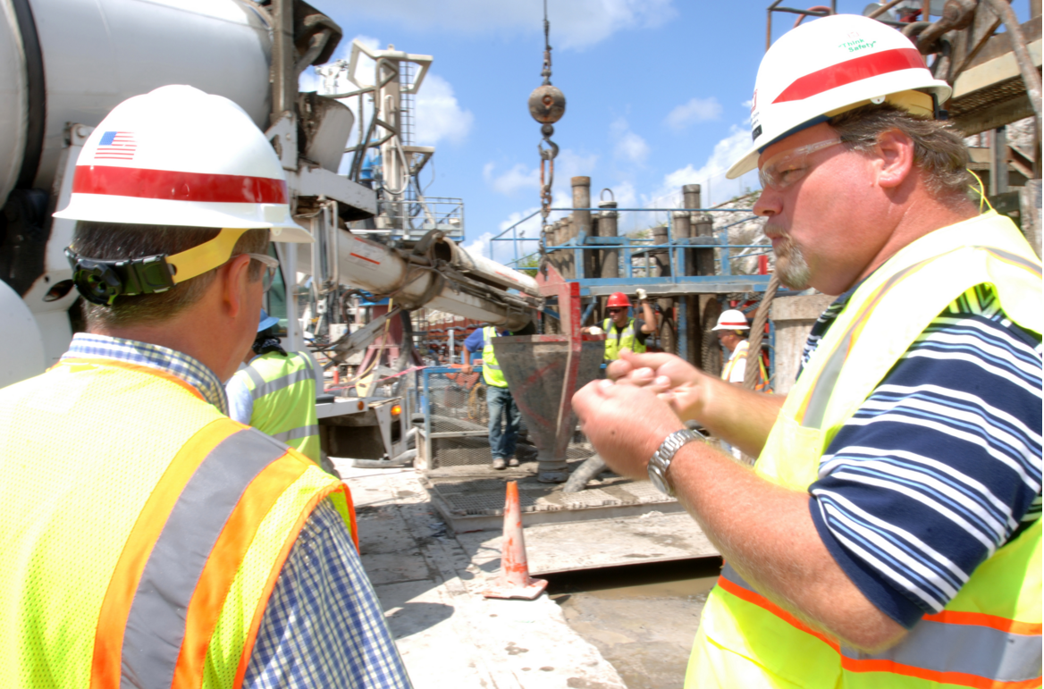
On a sheet of paper: Describe these people. Could you see yourselves in their shoes? What do they do all day?

