Purpose: To view open encumbrances by fund or organization code in Banner INB Production.
1.FGIOENC: Enter Chart =1, Fiscal Year, Fund and/or Org
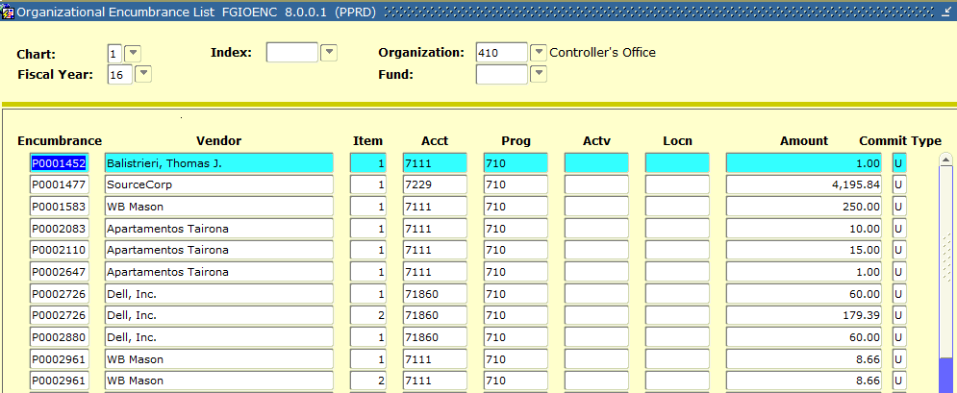
2. To view details, click Options, Query Detail Encumbrance Info.
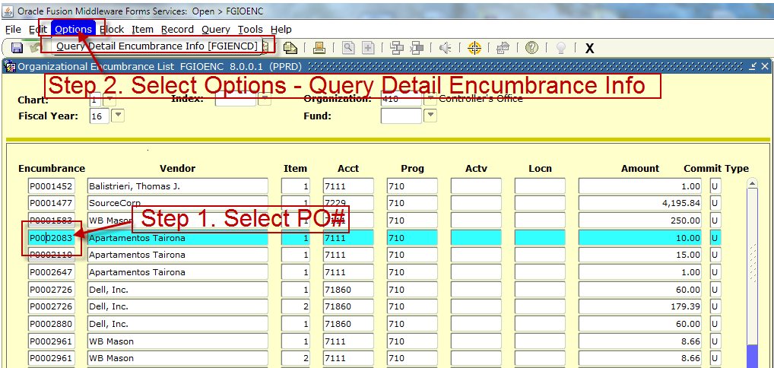
3. Original encumbrance, liquidation (payments) and balance is displayed. The lower half of the form details payment data. Example below shows payments made against a blanket PO.
