Purpose: To view open encumbrances by fund or organization code in Banner Self Service.
- Perform Budget Status by Account Query, click on an encumbrance amount:
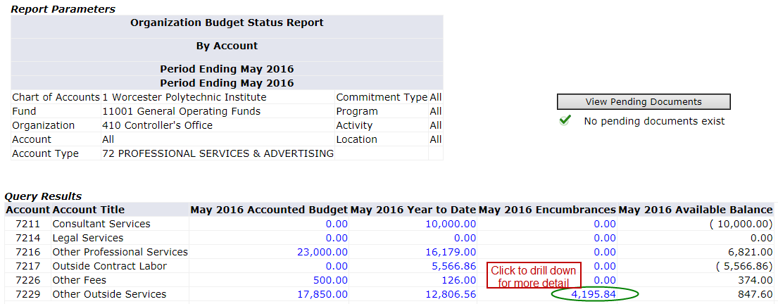
- You can drill down for even more detail by clicking on the PO document number:
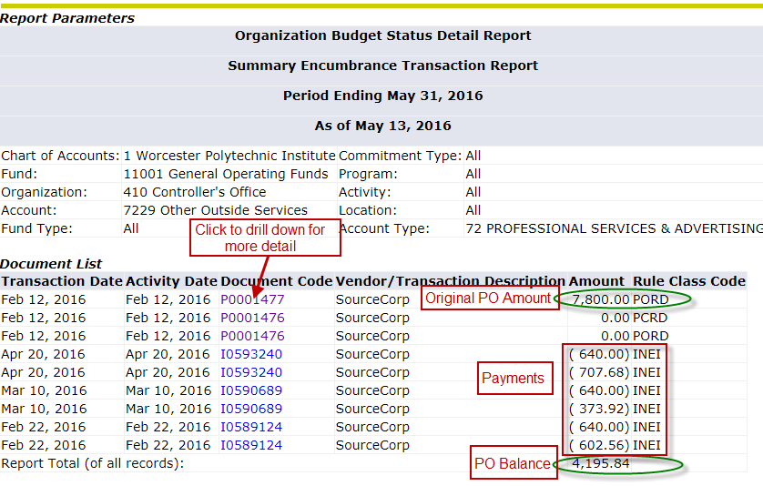
- Invoice documents and check numbers will be displayed:
