Login: http://www.wpi.edu/offices/finops/procurement.html

The FIRST TIME you log into STARS:

Select WPI from the drop down list and select remember my selection permanently.

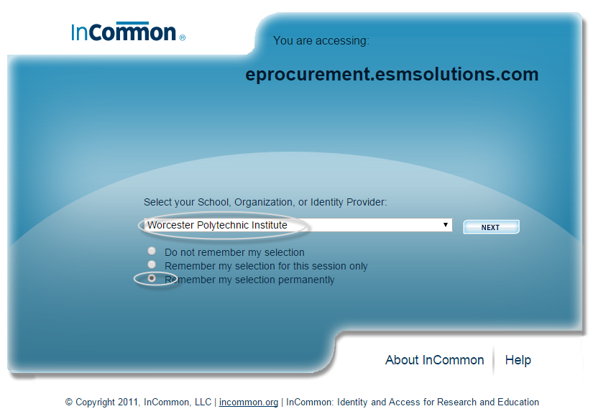

For subsequent logins use your WPI username and password.

The 5 steps of a Purchase Order:

- SHOP: Enter the items to purchase, either from a punch out or non-catalog vendor
- CART: Review order
- CHECKOUT: Enter FOAPAL(s)
- APPROVE: Approver rejects or approves order
- RECEIVE: Enter receipt of goods

Step 1: Create an order from a punch out catalog or non-catalog vendor

Select a punch out catalog or a non-catalog item.

What is a punch out catalog?
Punch out catalogs are integrated links to a supplier’s web based catalog with WPI pricing. Access the catalog by clicking on the supplier name to search and select products from the supplier’s web catalog. When finished shopping, follow the supplier’s checkout instructions. The items will move into the STARS cart.

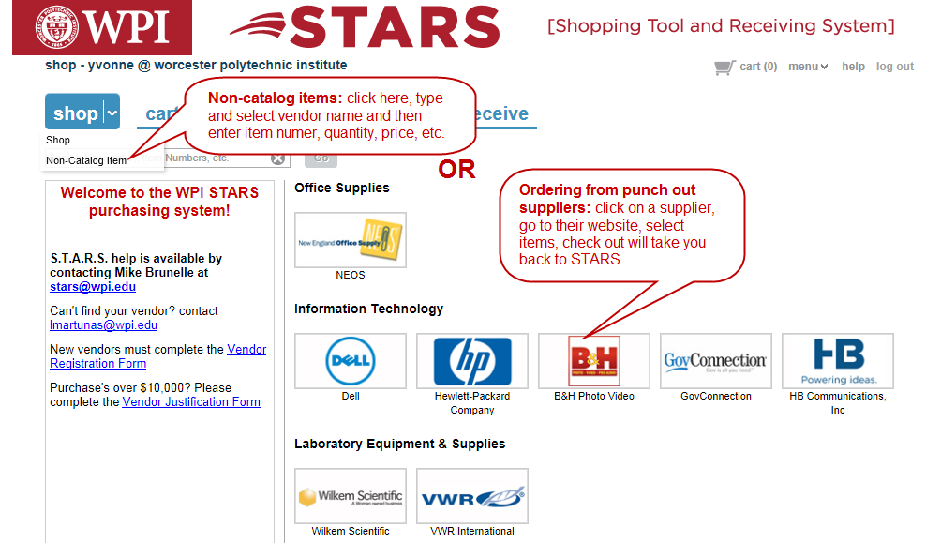

Order from a non-catalog vendor:

Click on the drop down arrow next to shop and select NON-CATALOG ITEM
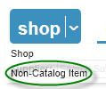

Enter the name of the vendor in the supplier box and press GO:
A list of the vendors with that name will appear, select the desired vendor and click NEW ITEM
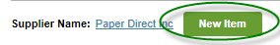

Complete the details for the items to be purchased. Items with * are required.

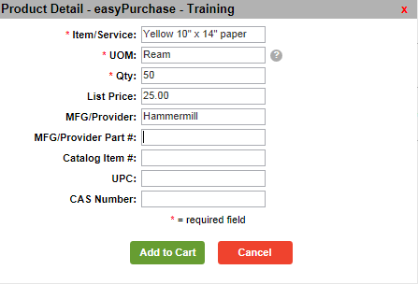

Click Add to Cart. Re-select NEW ITEM and repeat for each item to be ordered.

Step 2: Review cart, update quantities if desired and CONTINUE

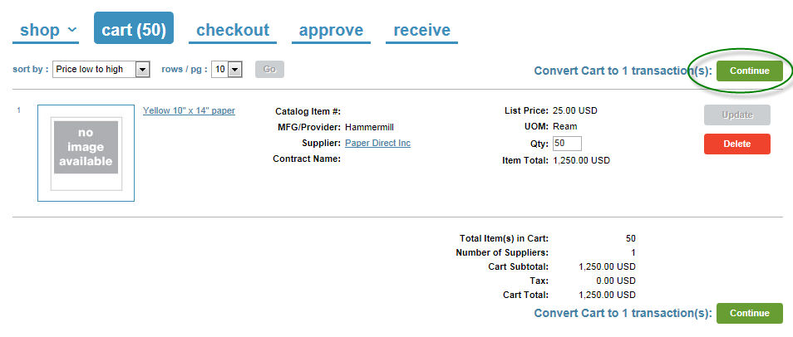

Step 3: Checkout to enter FOAPALs and add notes or attachments

- Click the arrow next to the 1 in the upper left corder. This will expand the order to display the line item detail. You may split foapal(s) if you desire.
- Release method is pre-determined by the supplier. Manual order-you submit PO to supplier, electronic order-STARS submits PO to the supplier.
- Order types: Standard, Blanket or Standing (see website for definition)
- Order comments/attachments will appear or be attached to the PO (if you have a quotation, attach here)
- Internal comments/attachments are visible only within WPI
- Contract number to be referenced (if available)
- Work Order# for use by Facilities department
- Ship to address may be edited by expanding to line item detail (click on arrow next to number in upper left corner)
- Enter FOAPAL either by selecting the drop down arrows or click on details to enter the FOAPAL(s)
- Click UPDATE

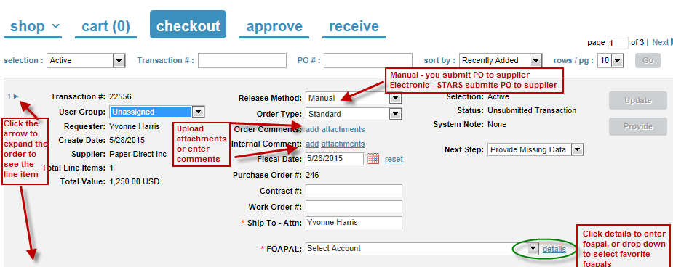

Once expanded, the line item detail will display.
Multiple FOAPAL(s) may be entered, split by either dollar or percentage:
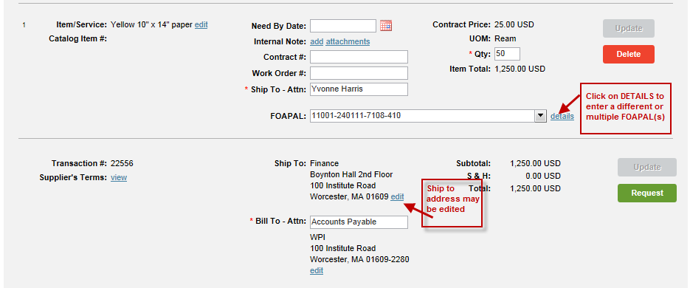

To enter a different or multiple FOAPAL(s):

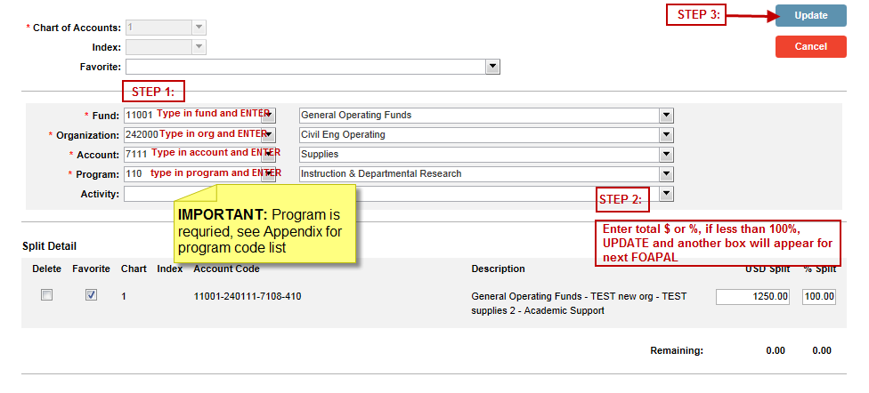
VALIDATE the transaction
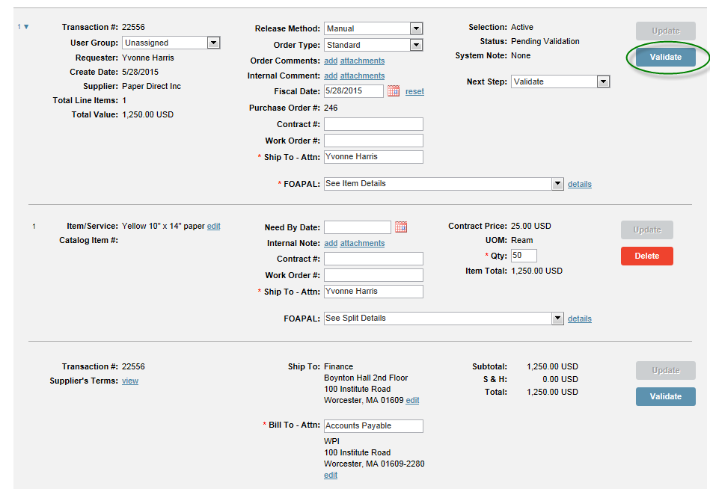

REQUEST approval to send the PO to the approval queue. An email notification will be sent to the approver with a link to access, review and approve or reject the transaction.
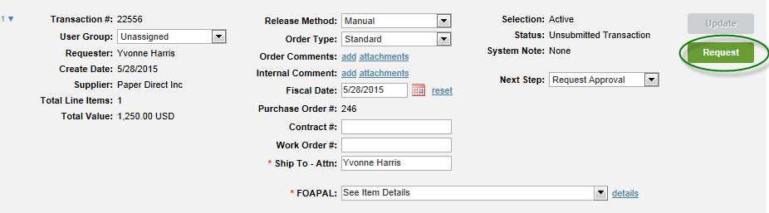

You may view the status of the approval queue
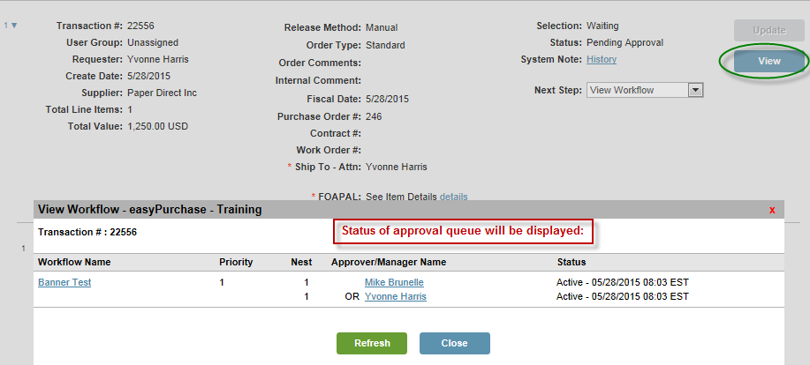

Step 4: Approve or reject transaction

The approver will receive an email message with a link to log into STARS. Review and either reject or approve the transaction.
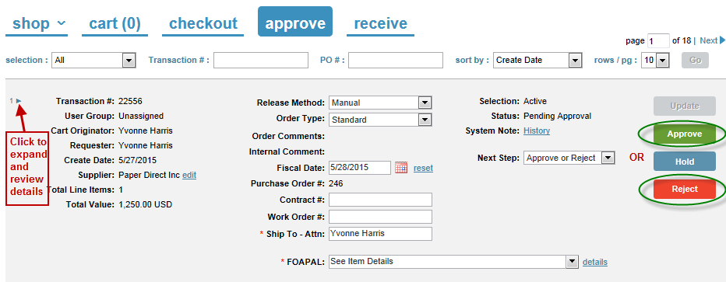

If rejecting a transaction, include a rejection reason for the originator.
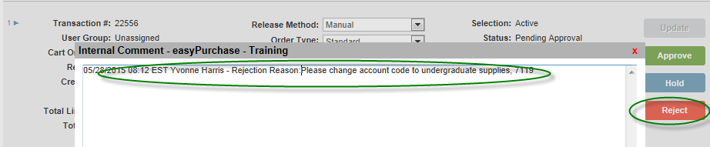

Upon approval of the transaction, the purchase originator will receive an email message to release the order to the vendor.

Sample email:
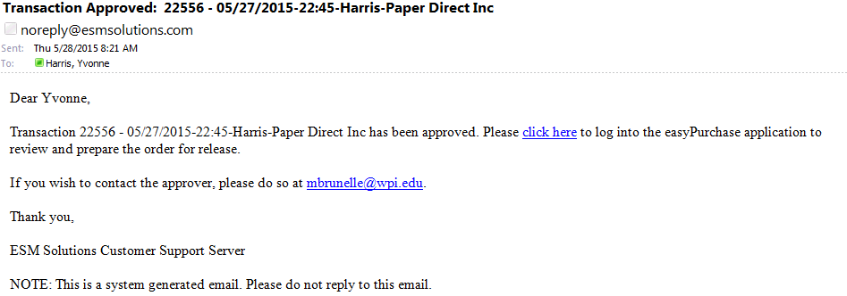

Step 4A: RELEASE the PO to the vendor (see CHECKOUT tab) & encumber the funds in Banner
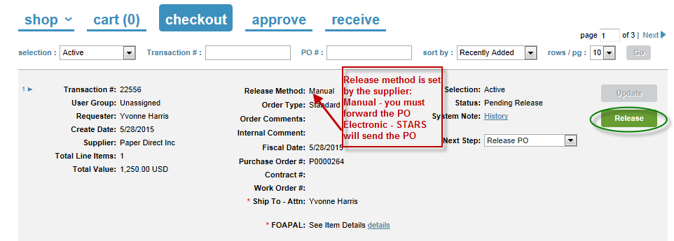

An image of the PO will appear, select Continue, Print or Cancel. You will receive an email message containing an image of the PO. For manual orders you may forward this to the supplier or print and fax or mail the order.

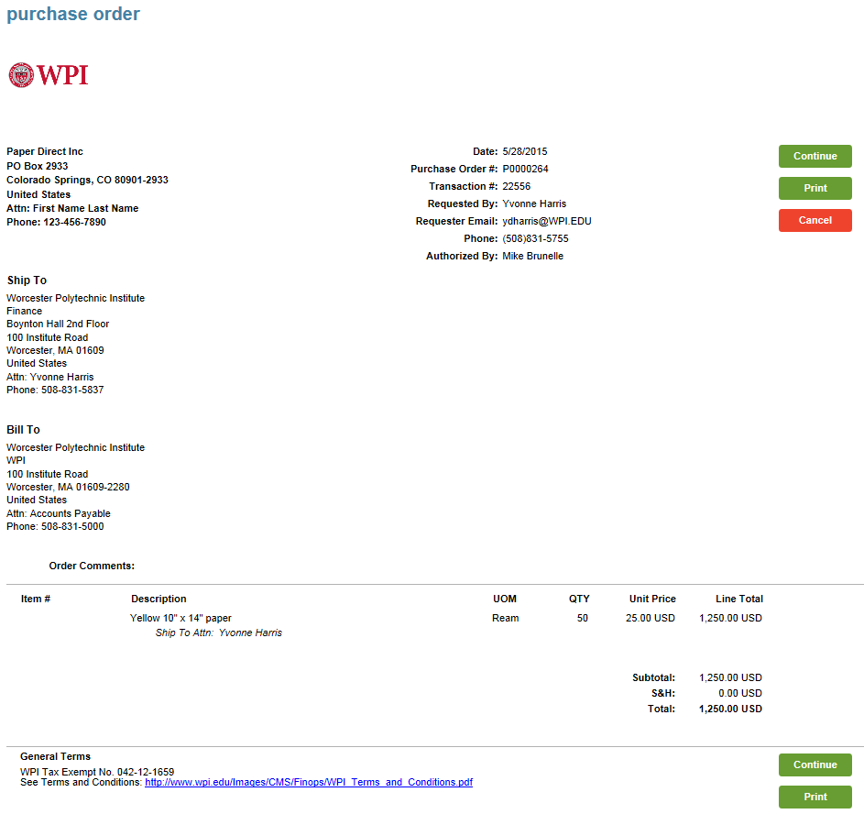

Step 5: Receive the order

Upon receipt of goods or services, expand the order to the line item detail.
Enter quantity or dollar value received.
Upload packing slip as attachment.
Update the order.
Close the order (blanket orders should remain open until final invoice is received).

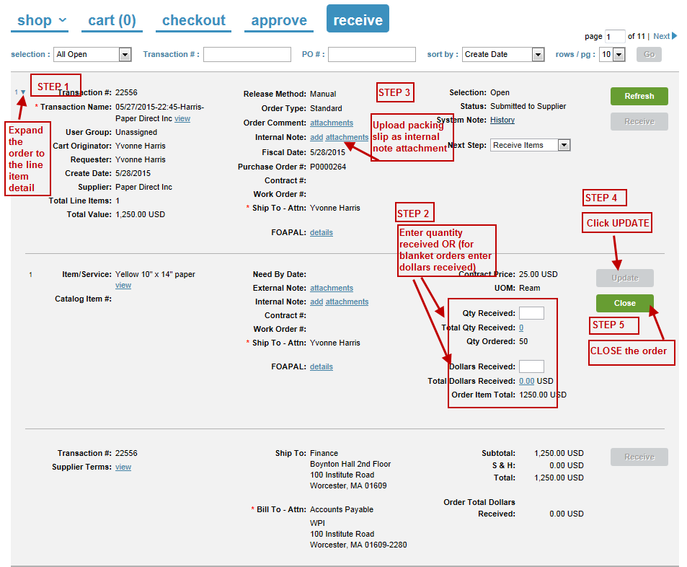

Vendor invoice should be emailed to STARS-INVOICE@WPI.EDU for processing. Include PO# and vendor in subject line. Banner encumbrance will be relieved upon invoice payment. No check request is required.

5/16/16
Appendix: Program code list OR see the program code lookup
The following table provides Banner program codes used by WPI to group expenses to the purpose for which the costs were incurred. These are used to summarize expenses by program or function for the university's financial statements, tax filings and various national surveys. Each fund or org has a corresponding program code and program codes are a required field in the FOAPAL string.
Please contact Charlene Bellows at extension 5877 or by email at cbellows@wpi.edu with any questions.
Program Code | Title | Description | Example Fund / Org
110 | Instruction & Departmental Research | Academic operating departments, MQPs, IQPs and other undergraduate/graduate programs and projects; certain department and faculty funds such as professional development funds | Fund 12670 (Professional Development); Fund 12280 (Department Fund)
120 | Other Educational Operations | Corporate and professional education (CPE), Biomanufacturing Education and Training Center (BETC), Healthcare Delivery Institute(HDI), sports teams and summer programs | CPE, Summer Programs, BETC, HDI
210 | S/R-Federal | Federal sponsored research | Funds 20XXXX & 21XXXX
220 | S/R-Non-Federal | Corporate and private foundation sponsored research | Funds 22XXXX
230 | S/R-Gifts | Certain gifts in support of research | Funds 227XXX
295 | Other Sponsored Programs | Mass Academy and industry sponsored centers | Funds 232XXX, 233XXX; Org 3500 (Mass Academy)
296 | Research Related | Overhead return and lab startup funds | Fund 17020 (Overhead); Fund 12770 (Startup)
310 | Communications | Marketing operating departments | Marketing Orgs
320 | Advancement | Advancement operating departments and government relations | Advancement & Alumni Relations
330 | Alumni Programs | Alumni office, reunion and homecoming events | Reunion, Alumni & Annual Funds
410 | Academic Support | IT, graduate admissions, academic deans, academic advising, OSP, library | Fund 16EXXX; Orgs for Library, IT, Deans, Advising, Sponsored Programs
510 | Student Services | Undergraduate admissions, enrollment management and financial aid offices; student services such as health, counseling, international affairs; campus center office | Orgs related to student services: admissions, fin aid, registrar, etc.
610 | Operation & Maintenance of Plant | Campus police, insurance, facilities operating departments | Orgs related to facilities, Police
710 | General Administration | Administrative offices - president, provost, VPR, VP of student affairs, finance, human resources, tech transfer, trustees, corporate engagement | Orgs related to president, provost, finance, HR, etc.
751 | Institutional Support | Mail services, procurement | Org 45XX, except 4520
2200 | Auxiliary Enterprises Expenditures | Student housing and dining, rental properties | Orgs 4520, 468XXX, 727XXX
3100 | Plant & Capital Expenditures | Projects included in the capital budget | Funds 16CXXX
5100 | Agencies | Student organizations | Funds 8XXXX

