Expense reports are submitted to reimburse you for business-related costs, such as airfare or hotel expenses, and to reconcile pcard transactions.
From the Expenses worklet:
- Click the Create Expense Report button under Actions.
- Select either Create New Expense Report or Copy Previous Expense Report.
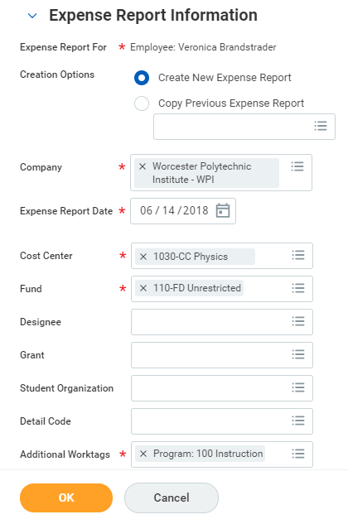
- Worktags determine which budgets are charged (i.e., Cost Center, Grant, Gift. Etc.). The Cost Center will default to your organization’s operating budget. [need to confirm this]
You can change the Cost Center by entering the number, or by searching for keywords. You can also a Grant worktag, or under Additional Worktags, a Gift worktag.
Note: When you enter a Cost Center, Grant, or Gift worktag, the related tags (Fund, etc.) change automatically.
- If you have created expenses on a mobile device, or have pcard items to reconcile, they will appear here. Choose the ones you wish to include in the current expense report. 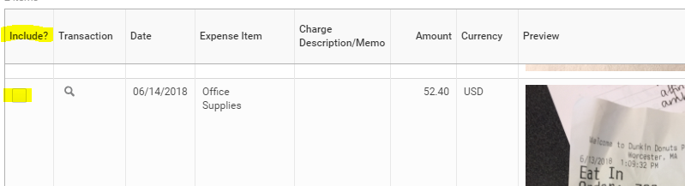
- Click OK.
DRAFT
- Complete the required fields, including Date, Business Purpose, Memo. 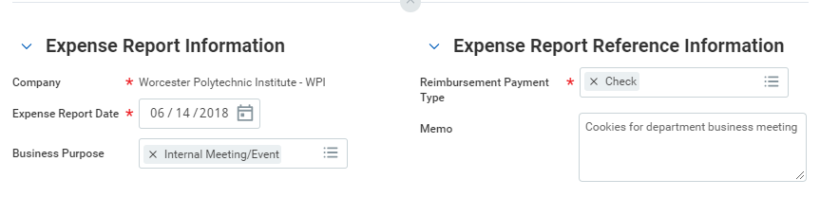
- For each item in the expense report, complete the required fields, including Expense Item (use the menu, or search for keywords like “airfare”), Amount, and Business Topics, Attendees (if you miss a required field, an error message points it out after you click Submit).
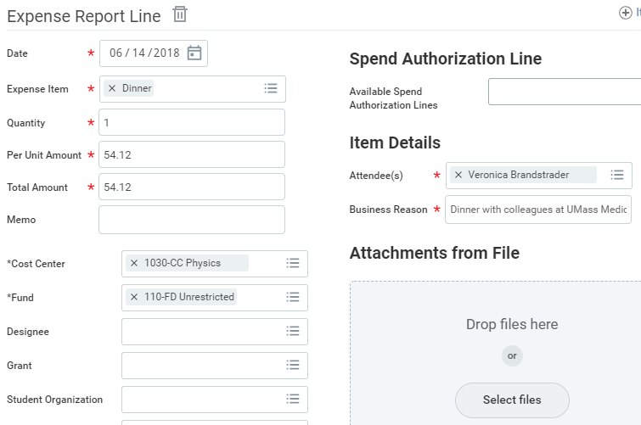
- You can leave the default worktags, or enter a Cost Center, Grant, or Gift worktag, which will update the related tags (Fund, etc.). If you need to further split an expense item, use the Itemize option, see below.
- Add any attachments as needed, preferably near each item, or on the Attachments tab. 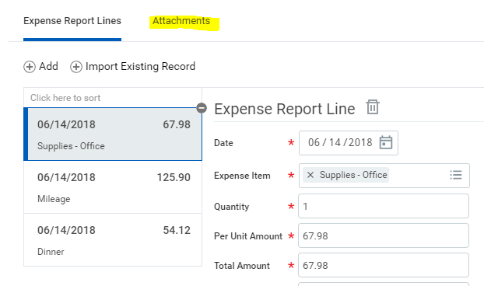

Itemize Your Expenses
Use this option to break out alcohol from a restaurant receipt, or split an expense between two cost centers. In an expense report:
- Enter the expense item, including Amount, then click Itemize. Itemization fields vary depending on the type of expense. 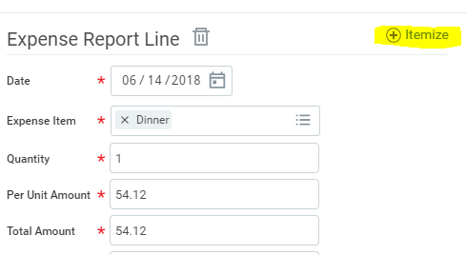
- Enter the information based on the expense. Itemized expenses must equal the total of the Expense Report Line; Workday calculates the remaining amount.
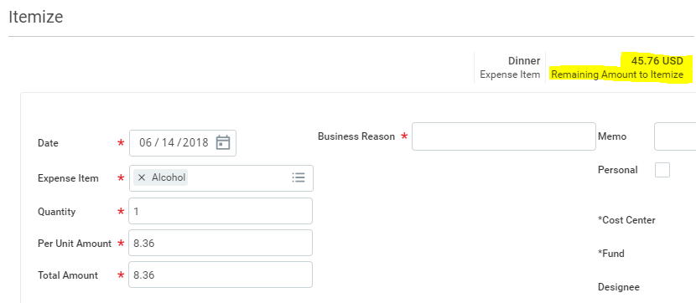
- When you’re finished click Done to return to the expense report.

View an Existing Expense Report
From the Expenses worklet, click the Expense Reports button under View. You can filter expense reports by status or date. You can also click the date of the expense report you want to view in the Recent section.
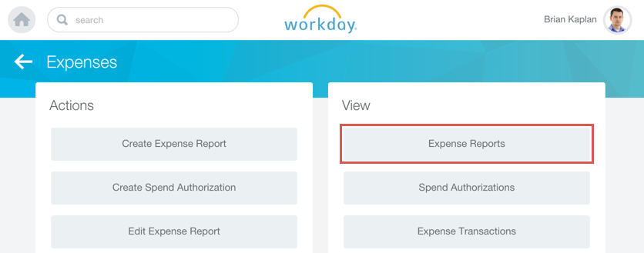
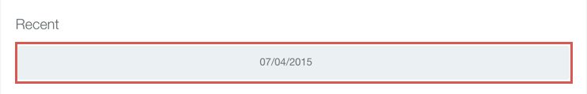

CHANGE an Expense Report
If an expense report is In Progress, you can update it. Use the Related Actions button next to the existing expense report and choose Expense Report > Change. You can then update and submit the expense report.

Mobile
Enter ExpenseS and Submit Expense Report
Use the Expenses icon to track expenses, upload receipts, and submit expense reports:
- Tap New Expense.
- Tap the Camera icon to take a photo of the receipt. Using an iPhone, you can also choose an existing photo or import an attachment. Using an Android, you can also select an existing photo from the gallery. If you take a photo, tap Use Photo.
- Enter an Amount, Date, and an Expense Item. You can navigate through the Expense Item menus or simply type a word to search for a category (e.g., “meals”).
- Tap Done.
Repeat previous steps to add any other expense items you want to report. When all expense items are added, you can submit an expense report from the Expense icon.
- Tap New Expense Report.
- Include the Company, Expense Report Date, Cost Center, and Region. [need to confirm this]
- Tap the Additional Worktags prompt if you are charging a Gift or use other Activity codes.
- Once you’ve completed the expense report information, tap Done.
- Tap Add Expense to attach expenses to the report.
- Tap Existing Expenses. You can also choose to add more expenses in this step by tapping New Expense.
- Choose the pre-existing expenses you want to include in the report by tapping the checkmark next to each expense item you have saved.
- Tap Done.
- Tap Review.
- Review your expense items for accuracy and correct any errors, then tap Submit. A confirmation screen shows your expense report has been routed for approval.
